 | MINISTRY OF EDUCATION AND TRAINING  FPT UNIVERSITY

Capstone Project Documents
[Project name]
<Group Name>
Group Members | <Member name><RollNo><Student code >  <Member name><RollNo>< Student code >  <Member name><RollNo>< Student code >  <Member name><RollNo>< Student code >  <Member name><RollNo>< Student code >
Supervisor
Ext Supervisor
Capstone Project code

Hanoi, August 2011

Record of Changes
Date | Change Item | Description | By | Version
10/06/2011 | All | Create the document | LinhNan | 1.0

Table 1-1: References

TABLE OF CONTENTS
Part 1 INTRODUCTION
TABLE OF CONTENTS 4
1 design overview 5
2 Architecture design 6
2.1 Choice of System Architecture 6
2.2 Architecture Design 6
2.2.1 Archiectural Presentation 6
2.2.2 Packages/Components Design 6
2.2.3 Deployment View 6
3 Detailed design 7
3.1 Common Components/Classes 7
3.2 Functional Design 7
3.2.1 <Function/Group function Name e.g. UC01001- Search Staff> 7
3.3 Database Design 7
3.3.1 Entity-Relationship Diagram 7
3.3.2 EXPERT table 7
3.3.3 STAFF table 7

Design overview

Overview
- This document describes the technical and UI design of the TFM system. It includes the architectural design and the detailed design of common functions and business functions. It also includes the design of database model, and overall design of user interface.
- The architectural design describes the overall architecture of the system, and the architecture of each main component and subsystem. It will describe the patterns being used, the role of each component and the role of the system in the working environment.
- The detailed design describes static and dynamic structure for each component and function. It includes class diagrams, class explanations, and sequence diagrams of the main use cases. The detailed design uses notations of .NET framework 4.0 and C# 4.0 as they are the framework and language for developing the system.
- The database design describes the relationship between entities, and details of each entity. It uses notations of SQL Server 2008 as it is the database server for developing the system.
- The user interface design describes the layout of the system, and some design for the screens.

Definition and acronyms
Acronyms | Definition | Note
TFM | Toll Fee Management | Name of project
PNRS | Plate Number Recognition System | Name of main application that’s used to recognize plate number.
TCMW | Toll Collection Managerment Website | The website that’s used to manage toll collection.

Table 1-2: Definition and acronyms

Architecture design

Basic Structure
Basic structure of the system is described in the following figure:

Database
Server
TCMW
DSS
Vietnam Register System database
Web service
Clients
Browser
PNRS app
Get data
Update data

Architecture Design

PNRS Components Design
The following diagram describes components of PNRS.
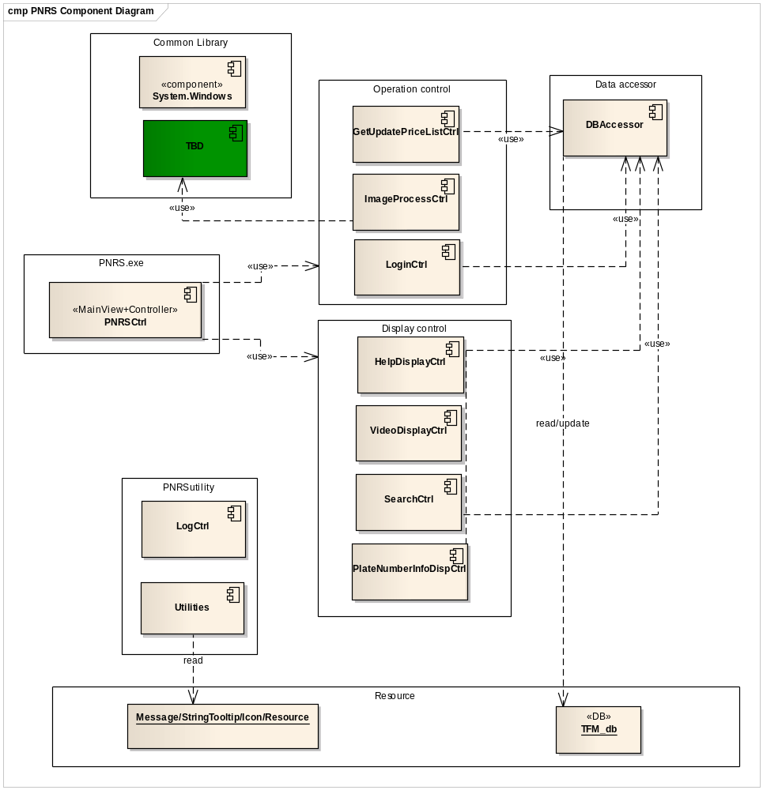

No | Component name | Component type | Language | Mô tả
1 | PNRSCtrl | Main Contrller | C# | - Main controller of PNRS, controls main business of PNRS.  - Load and manage all GUI components to create main screen of PNRS.
2 | LoginCtrl | Operation control | C# | - Entry point of PNRS, control loging in and switching user in PNRS of users.
3 | ImageProcessCtrl | Operation ctrl | TBD | - Main core of PNRS, provide features to process place number recognition: receive signal from sensor, shot image and recognize it.
4 | GetUpdatePriceListCtrl | Operation control | C# | - This component process viewing and updating latest price list.
5 | HelpDisplayCtrl | Display control | C# | - Show usage guideline to user.
6 | VideoDisplayCtrl | Display control | C# | - Process getting image information from camera and displaying on screen.
7 | SearchCtrl | Display control | C# | - Control all search activities of user on PNRS, provide features for user to search and display result on screen.
8 | PlacaNumberInfoDispCtrl | Display control | C# | - Display place number info after recognizing activity.  - Provide features for users to manipulate when PNRS cannot recognize inputed image.
9 | DBAccessor | Data accessor | C#
10 | LogCtrl | PNRS utilities | C# | - Provide features to process logging file, logging event for tracing bugs if have.
11 | Utilities | PNRS untilities | C# | - Provide all common such as constants, common methods that all components of PNRS use

TCMW Components Design

DSS Components Design

Detailed design

Common Components/Classes
<Describe the common components/classes that are used in the application>

Functional Design

<Function/Group function Name e.g. UC01001- Search Staff>

Screen Design
<This section is used to describe the screen of the function/group functions. If there is no screen for the function, this section should be removed>

Class Diagram

Sequence Diagram

Flow/Activities Diagram
<This section is used to describe the flow charts of the function/group functions. If there are no flow charts for the function, this section should be removed>

Database Design

Entity-Relationship Diagram

EXPERT table

STAFF table

Appendix 1: ….

